Minos Problems
Name_________________

Date__________________

“The Magnet”

The steel MINOS Far Detector consists of two large sections, or supermodules. The coil of one of the supermodules consists of 180 wraps of 1/0 cable, with each wrap of cable carrying about 80 A each. The Far detector is 30 m long and has a gross mass of 5400 tons.

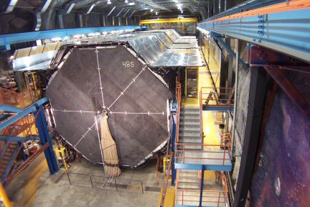

1. Using the right hand rule, sketch one wire with the current running into the page. Draw
the magnetic field that would be generated in this wire.

2. Assuming the coil makes a toroidal magnet, calculate the magnetic field strength at a
distance of 2 m from the center of the coil.

